

Sukkur IBA University [Kandhkot Campus]
Department of Computer Science
PHY-111: Applied Physics

Handout # 01: DC Circuits

Instructor: Engr. Muhammad Ismail Qureshi

Note: Submit this lab hand-out in the next lab with attached solved activities and exercises

Submission Profile

Namevishaka Submission date ( / / ):

Marks obtained: Receiving authority name and signature:

Comments:

_____________________________________________________________________________________

Instructor Signature

Lab Learning Objectives:
The objective of this experiment is to use Ohm's Law to determine the resistance of several individual resistors and the equivalent resistance of series and parallel combinations. You will apply various voltages across the resistor (or circuit) using a power supply, and measure the current I through the resistor and the voltage V across the resistor for each setting of the power supply.

From a plot of V vs. I, you will determine the resistance. You will compare the measured value of the resistance with the manufacturer's value.
Lab Hardware and Software Required:
Variable DC power supply, Breadboard, Resistors of different values, Multimeters & connecting wires.

Background Theory:
Ohm’s Law:
German Physicist George Simon Ohm (1789-1854) published this law in 1827 after conducting studies on the relationship between the applied voltage and current flowing through various length of wire. Statement of this law is;
At moderate constant temperature with other physical conditions remaining unaltered, the magnitude of electric (I) through a conductor is directly proportional to the potential difference (V) applied across ends.
Mathematically this law can be expressed as;
𝐼 ∝ 𝑉
𝑉 = 𝑅𝐼

1
Where R is constant of proportionality known as resistance and 𝐺 = is known as the
𝑅 conductance. R is measured in Ohms (Ω) and G is measured in Mho.

Limitations of Ohm’s Law:
Ohm’s law hold good only for metallic conductors at moderate temperatures. At very low and very high temperatures even metallic conductors do not obey ohm’s law. This law is not obeyed by Vacuum tubes, discharge tubes, semiconductors and electrolytes.

Resistors & Resistance:
Resistor is a two terminal electrical component that limits or regulates the flow of electric current in a circuit. Resistance is the property of a resistor by which it opposes the flow of an electric current.
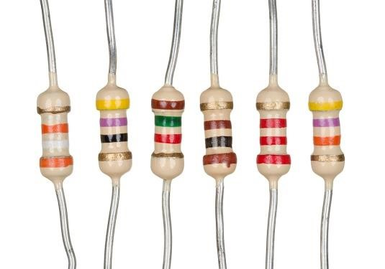
You will notice coloured bands on the resistors. These bands form a code that indicates the resistance of the resistor. Later we will discuss how to read this colour code.

Combinations of Resistors:
Resistors can be combined in simple circuit arrangements that increase or decrease the over- all resistance in the circuit. These arrangements are called series and parallel circuits.

- Series Combination:

Resistors are said to be connected in series between two points if there is only one path for the current to flow between two points.
OR
When two or more resistors are connected in an end to end manner then they are said to be connected in series.

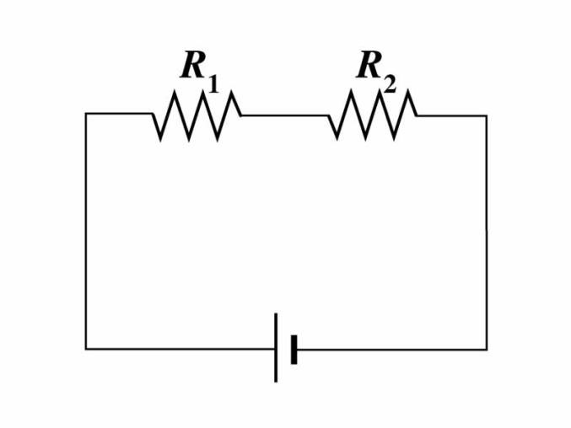
Total equivalent resistance in series combination will be: 𝑅_{𝑇}=𝑅₁ + 𝑅₂ + 𝑅₃ … . 𝑅_{𝑛}

Where n represents number of resistors connected in series combination.

- Parallel Combination:
Resistors are said to be connected in parallel if current has more than one path to flow in the circuit.
OR
Two or more resistors are said to be connected in parallel if one end of each resistance is connected at one common point and other end of each resistor is connected to another common point.

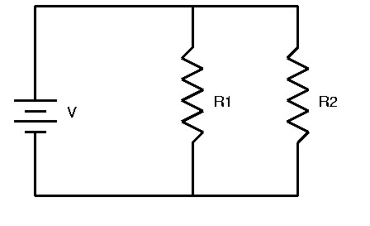
Total equivalent resistance in parallel circuit is given as;
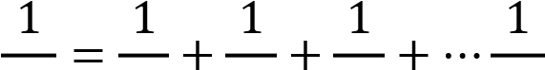
𝑅𝑇 𝑅1 𝑅2 𝑅3 𝑅𝑛

Where n represents the number of resistors connected in parallel.

Measuring Current and Voltage:

Ammeters are used to measure the current owing in a circuit. To do so, the ammeter should be connected in series with the circuit element through which you want to measure the current. Introducing an ammeter into a circuit should not affect the flow of current in the circuit and, therefore, ammeters have very low resistance.

Voltmeters are used to measure the potential difference or voltage drop across a circuit element. To do this, the voltmeter should be connected to the two points across which you want to measure the potential difference. In other words, the voltmeter should be connected parallel to the circuit element. Voltmeters should not affect the current flowing through the circuit element and, therefore, voltmeters have high resistance. This prevents current from flowing through them.

Reading the Resistor Code:

The resistance of most ceramic resistors can be determined from the colored bands printed on the resistor. Each color represents a digit from 0 to 9.
Color | Code | Color | Code
Black | 0 | Green | 5
Brown | 1 | Blue | 6
Red | 2 | Violet | 7
Orange | 3 | Grey | 8
Yellow | 4 | White | 9

The first two bands indicate the mantissa of a number in scientific notation; the third indicates the power of ten. The fourth band indicates the tolerance or the uncertainty expressed as a percentage in the value of the resistance (gold: 5%, silver: 10%, no 4th band: 20%). Therefore, in order to know which end of a resistor to start from when reading the color code, it is useful to remember that the 4th band, if present, is metallic in color (gold or silver). If regular colours are present instead of these metallic bands, sometimes the color bands will be spaced differently or are closer to one end of the resistor to help indicate which end to start reading from. We will not be concerned with five-band resistors in this lab. If a fifth band were present, the first three bands indicate the mantissa, the fourth indicates the power of ten and the fifth indicates the tolerance (as brown, red, orange, yellow, or gold). See the example in Fig. 3 below.

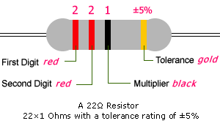

Lab Examples
Available with lab activities

Lab Activities

You will set up a simple DC circuit with a single resistor and measure the current flowing through the resistor and the potential difference across it. From a plot of voltage versus current you will determine the resistance of the resistor. You will repeat this process with the second unknown resistor.

You will use the two unknown resistors to set up a series combination and experimentally determine the equivalent resistance of the combination and compare it to the theoretical equivalent resistance.

You will connect the two resistors in parallel and find the equivalent resistance of this parallel combination and compare this equivalent resistance to the theoretical equivalent resistance.

Procedure A: Determining Resistor Value Using Color Code

- Enter the color of the four bands for the two resistors in Data Table 1.
- Determine the resistor value for the resistors, and enter these values in Data Table 1. You will use these values as the expected or manufacturer's values when comparing with the experimental values.

Procedure B: Determining 𝑹_{𝟏}

To determine the resistance, you will set up the following circuit.
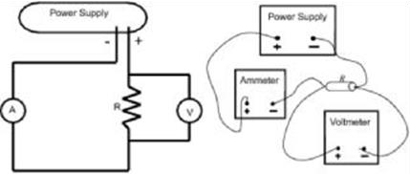
- Make sure your power supply is turned off.
- Connect the circuit as shown in the figure above.

Precaution: If the multimeter’s are not set to the proper scale, it can damage the meters.

- Set the power supply to deliver 3 V. Record the ammeter and voltmeter readings on your worksheet. Record the actual voltmeter reading and not the value on the power supply as
these two readings might be slightly different.
- Increase the power supply output in steps of 1 volt and record the ammeter and voltmeter readings on your worksheet, for a total of five different voltmeter readings.

- Construct a graph of V versus I using Excel.
- Compute the percent error between the manufacturer's value of the resistance (from Data Table 1) and the experimental value.

Procedure C: Determining R₂

- Disconnect the first resistor and connect the second resistor
- Repeat the steps 3-8.
- Compute the percent error between the manufacturer's value of the resistance (from Data Table1) and the experimental value.

Procedure D: Determining Equivalent Resistance-Series Arrangement

- Connect the two resistors you used before in a series arrangement. Connect one multimeter in series with the two resistors to read the current flowing in the circuit.
- You will use the other multimeter as a voltmeter for measuring the potential difference across the series combination.
- Set the power supply to deliver 3 V. Record the voltmeter reading across the combination and the ammeter reading in the first two columns in Data Table 4 on the worksheet.
- Repeat steps 14 and 15 for four more readings of the power supply.
- Use the 2nd and 3rd columns of Data Table 4 to draw a graph using Excel and determine the equivalent resistance of the series combination from the slope of the graph.
- Compute the theoretical equivalent resistance of the series combination using Eq. 1and the values from Data Table 1.
- Enter the values of Rmeas and Rcal in columns 4 and 5 in Data Table 4 on the worksheet.
- Compute the percent error between the measured and calculated values of the equivalent resistances. Record this on the worksheet.

Procedure E: Determining Equivalent Resistance-Parallel Arrangement.

- Connect the two resistors you used before in a parallel arrangement. Connect the voltmeter to measure the potential difference across the parallel combination.

- You will use the second multimeter as an ammeter to measure the current I flowing out of the power supply. To do this you will first connect the ammeter in series with the power supply to measure I.

- Set the power supply to deliver 3 V. Record the voltmeter reading in the 2nd column in Data Table 5 on the worksheet.
- Measure I the current flowing from the power supply enter these in column 3 in Data Table 5 on the worksheet. 24. Repeat steps 23 and 24 for four more readings of the power supply.

- Use the 2nd and 3rd columns of Data Table 5 to draw a graph.
- Compute the theoretical equivalent resistance of the parallel combination using Eq. 2 and the values from Data Table 1 and enter the values in 4th column.
- Compute the percent error between the measured and calculated values of the equivalent resistance. Record this on the worksheet.
- Compare the measured and calculated equivalent resistances respectively in the circuit by computing the percent difference between the two values. Record these in Data Table 5.

Lab Exercises:

Please refer to the Worksheet of the Lab.

Detailed readings:

Fundamental of Physics, David Halliday, John Wiley & Sons, 9th ed.

Reference Text(s)

Worksheet

Circuits

As you work through the steps in the lab procedure, record your experimental values and the results on this worksheet. Use the exact values you record for your data to make later calculations.

Procedure A: Reading the color code of unknown resistors
Complete the data table 1 below
Resistor | Band 1 |  | Band 2 |  | Band 3 |  | Resistance
 | Color | Value | Color | Value | Color | Value | Ω
1 | orange | 3 | blue | 6 | black | 0 | 36ohm
2 | yellow | 4 | grey | 8 | brown | 1 | 480ohm

Procedure B: Experimentally determining the resistance of resistor

Data Table 2

Trial | Voltage (V) | Current (A)
1 | 3V | 83.33mA
2 | 4V | 111.11mA
3 | 5V | 138.89mA
4 | 6V | 166.67mA
5 | 7V | 194.44mA

What is the experimental value of R 1 (from your plot of voltage versus current)?

What is the percent error between the experimental and accepted values of R₁?

Is your measured resistance value in close agreement with the accepted value from Data Table 1?
(Consider your percent error exactly as you have entered it.)

Procedure C: Experimentally determining the resistance of resistor.
Complete the data table below for R₂.

Data Table 3

Trial | Voltage (V) | Current (A)
1 | 3V | 6.25mA
2 | 4V | 8.33mA
3 | 5V | 10.417mA
4 | 6V | 12.5mA
5 | 7V | 14.583mA

What is the experimental value of R₂ (from your plot of voltage versus current)?

What is the percent error between the experimental and accepted values of R₂?

Does your measured resistance value agree with the expected value within the measured tolerance?

(Consider your percent error exactly as you have entered it.)

Procedure D: Series Arrangement

Complete the data table below for the series arrangement. Take V_{meas} to be the voltage across the combination of resistors.

Data Table 4

Trail | Vmeas | Current | Rmeas | Rcal | %
 |  | (A) meas |  |  | Difference
1 | 3V | 5.81mA | 516ohm | 516ohm | 0%
2 | 4V | 7.75mA | 516ohm | 516ohm | 0%
3 | 5V | 9.69mA | 516ohm | 516ohm | 0%
4 | 6V | 11.628mA | 516ohm | 516ohm | 0%
5 | 7V | 13.567mA | 516ohm | 516ohm | 0%

Plot of voltage versus current graph:

Procedure 4
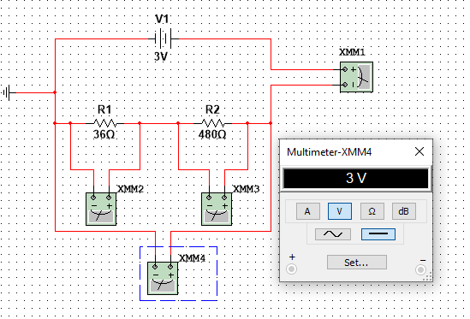
Is your measured resistance value in close agreement with the calculated value?

The measured and calculated values are equal, showing perfect agreement due to ideal simulation conditions

Procedure E: Parallel Arrangement

Complete the data table below for the parallel arrangement. Take I_{meas} to be the current from the power supply.

Data Table 5

Trial | V_{meas} (V) | I_{meas} (A) | Rcal | Rmeas | %  difference
1 | 3V | 89.583mA | 33.488ohm | 33.488ohm | 0%
2 | 4V | 119.44mA | 33.488ohm | 33.488ohm | 0%
3 | 5V | 149.31mA | 33.488ohm | 33.488ohm | 0%
4 | 6V | 179.17mA | 33.488ohm | 33.488ohm | 0%
5 | 7V | 209.03mA | 33.488ohm | 33.488ohm | 0%

Plot of voltage versus current graph:

Is your measured resistance value in close agreement with the calculated value?

The measured and calculated values are in very close agreement, with a negligible difference due to rounding off.

Procedure E
